**COVID – 19 Vaccinations Analysis**

**Introduction:**

* The COVID 19 pandemic caused due to the Corona virus devastated the world by causing several fatalities around the world.
* This virus originated in Wuhan, China in 2019 and was later spread throughout the world due to human contact in one way or the other.
* The disease showed symptoms as basic as mild fever and cold but also caused life threatening symptoms like breathing problems caused by damage to the lungs.
* In later stages of 2020 several experimental vaccines were developed and was administered to humans.
* The efforts were successful as the vaccines were helpful in reducing the affects the virus and even if people were infected, they were not in any life threating situation and escaped the illness having only minor symptoms.

**Problem Statements:**

* In this project we have analyzed the top 10 fully vaccinated countries.
* We have analyzed the top 5 vaccinated countries.
* We have analyzed the top 5 daily vaccinating countries.
* We have analyzed the total number of daily vaccinations, people who have fully vaccinated, people who is vaccinated.
* We have analyzed year wise daily vaccinating details, fully vaccinated people details, vaccinated people details.
* We have analyzed the country wise vaccines and iso_code details.

**Methodology:**

There are three steps involved in data science analysis they are

* Data Importing.
* Data Cleaning.
* Analysis.

**Step 1:**

**Data Importing:**

In power BI desktop with the help of the get data option import the CSV data which is named as country vaccinations and clicked load option.

**Step 2:**

**Data Cleaning:**

After loading the data and after analyzing the data understood that there are 86512 rows and 15 columns. And in that some of the columns contained null values I have replaced the null values by 0 with the use of replace functions and started working on the data.

**Step 3:**

**Visualizations:**

In visualization part with the help of power BI desktop software I have used different kinds of charts, graphs, cards and table to display the data in the format which will be easy to understand.

**Analysis:**

* In the analysis part first | have analyzed the top 10 fully vaccinated countries by using area chart and have used the filter option to find the top countries and the result obtained as below,
* From the below image we can able to come to know that India is the top country in terms full vaccination with 116 billon , followed by united states of America and china with 67 billion and 35 billion respectively.

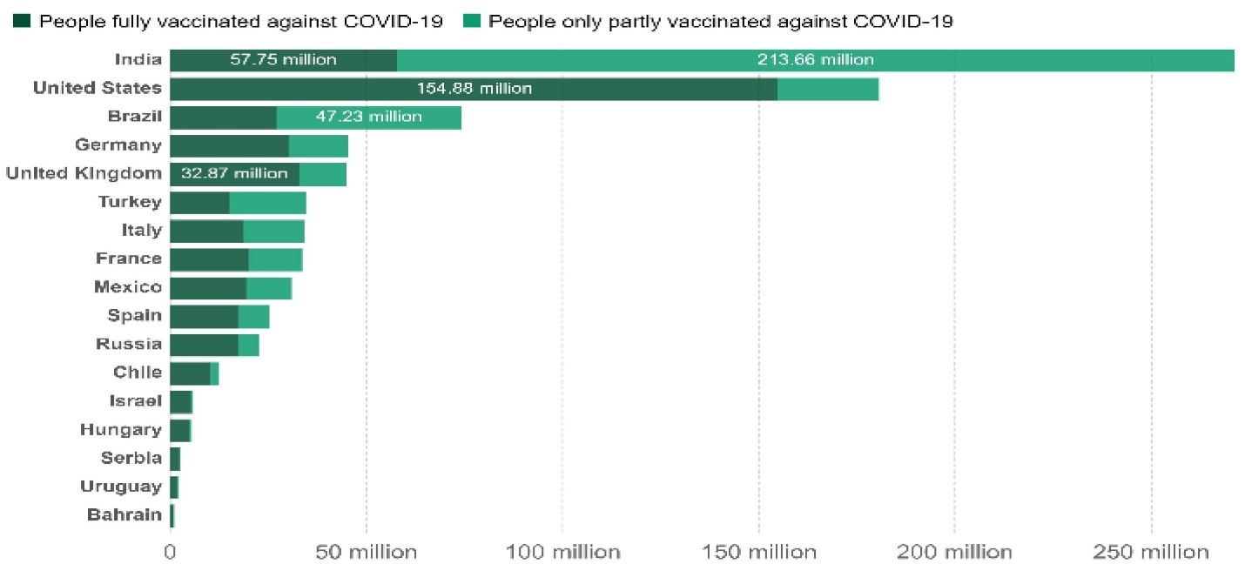

* In the second analysis we have analyzed the top 5 vaccinated countries with the help of pie chart and used filter option to find the top countries and with that we came to know that India is the top country with more number of vaccinated peoples followed by United States of America and Brazil.

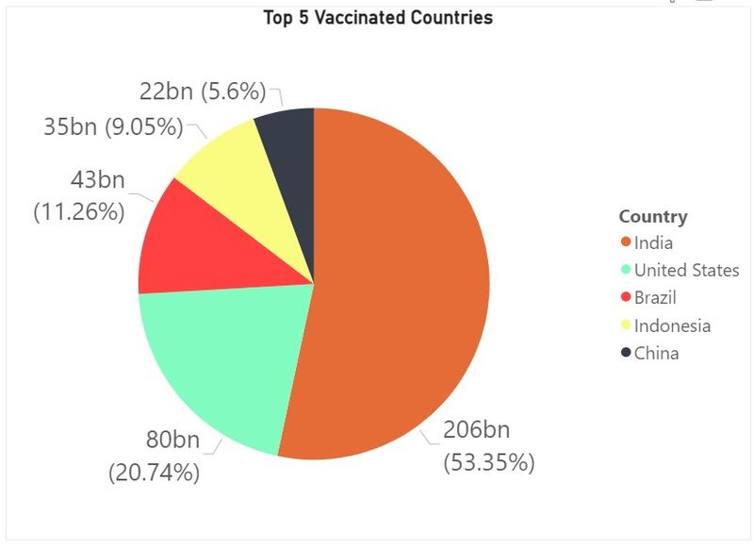

**Recommendations:**

* We should collect day to day reports and we should update our records daily to get more accurate details.
* So that we can move forward with more vaccination to the right country which needs the most.